Mesos

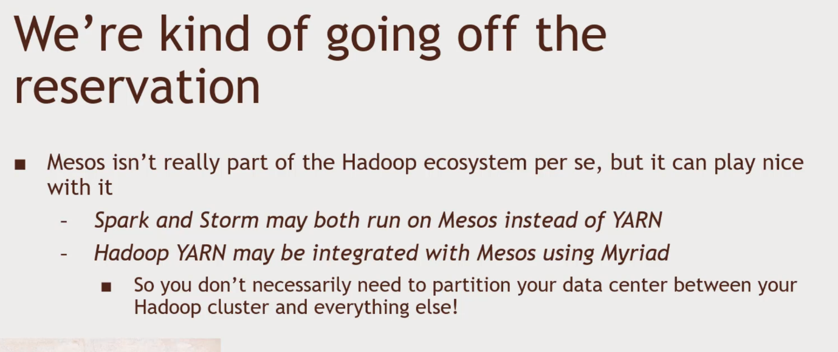

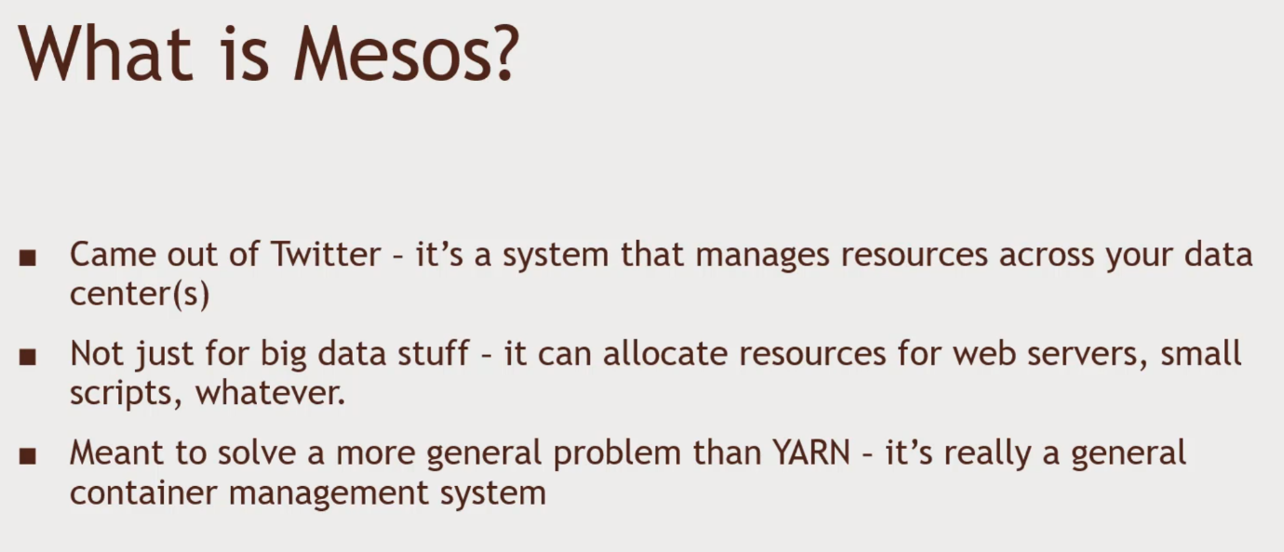Differences between Mesos and YARN

* YARN is a monolithic scheduler – you give it a job, and YARN figures out where to run
* Mesos is a two-tiered system
  + Mesos just makes offers of resources to your application (‘framework’)
  + Your framework decides whether to accept or reject them
  + You also decide your own scheduling algorithm
* YARN is optimized for long, analytical jobs like you see in Hadoop
* Mesos is built to handle that, as well as long-lived processes (servers) and short-lived processes as well.

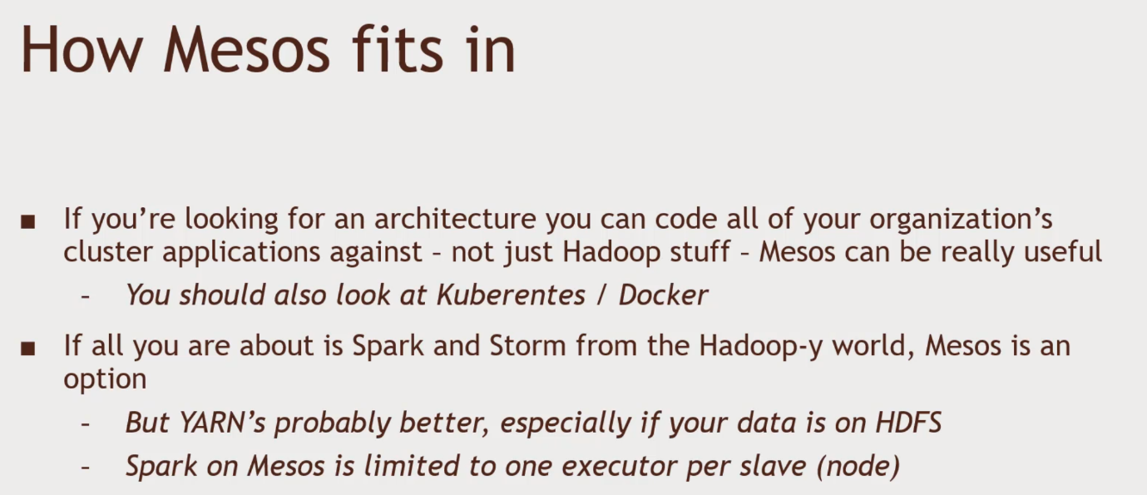 Siloed vs resource sharing

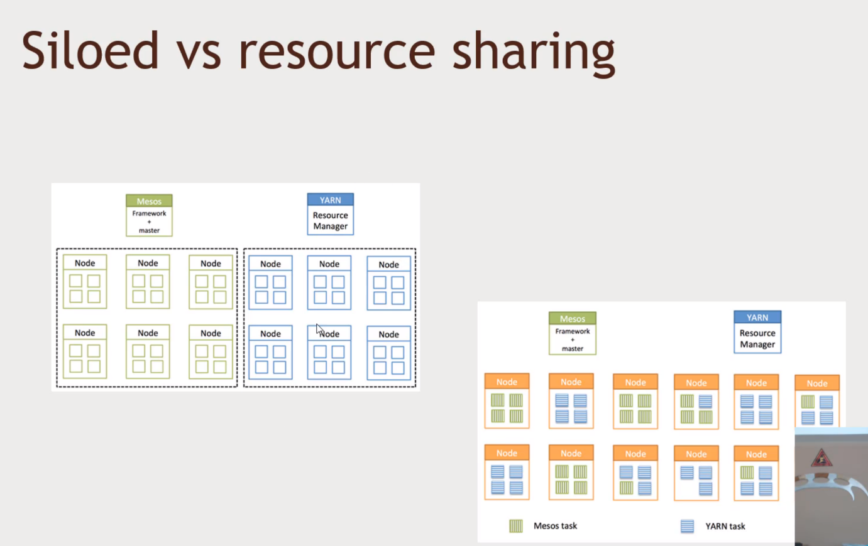You might be underutilizing the Hadoop architecture. Tying Mesos and YARN using Myraid

When to use Mesos?

* If your organizing as a whole has chosen to use Mesos to manage its computing resources in general
  + Then you can avoid partitioning off a Hadoop cluster by using Myraid
  + There is also a ‘Hadoop on Mesos’ package for Cloudera that bypasses YARN entirely
* Otherwise- probably not.